Join The Bungalow Youth Project

A space where young people belong

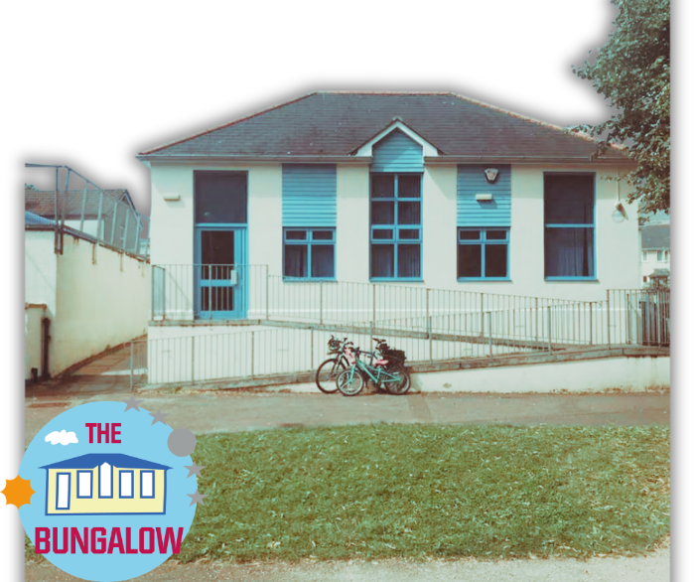

On behalf of the Board of Trustees, I’m pleased to introduce these opportunities to join The Bungalow Youth Project.

Over the past few years, The Bungalow has grown into something I am incredibly proud of — a space where young people come not just to take part, but to belong.

This work matters deeply to me. I have seen young people walk through our doors unsure of themselves, and over time grow in confidence, find their voice, and begin to shape their own futures. That doesn’t happen through programmes alone — it happens through relationships, consistency, and care.

As we move into an exciting new chapter with five years of National Lottery funding, we are growing our team. This is a real opportunity to join something that is evolving, thoughtful and rooted in young people’s lives.

I am looking for people who understand that youth work is not about having all the answers, but about being present, building trust and working alongside young people as they grow.

If that way of working speaks to you, I would really encourage you to apply.

Fanny Jackson
Charity Director
The Bungalow Youth Project


About The Bungalow Youth Project

The Bungalow Youth Project is part of Buckfastleigh Community Development Project (Trust), a registered charity established in 2002 to support young people and the wider community.
Based in the heart of Buckfastleigh, The Bungalow is a dedicated youth space where young people are welcomed as they are. We offer open-access sessions shaped by their interests, needs, and voices.
Our work is relationship-led and trauma-informed. We understand that behaviour is communication and prioritise creating a safe, consistent environment where young people can build trust, feel a sense of belonging, and grow in confidence.
At The Bungalow, young people are not passive participants — they actively shape what happens here. From activities to environment, their voice matters.
Food is a central part of our practice. Sharing meals creates connection, routine, and a sense of home within the space.
We support young people to:
- Build confidence and self-awareness
- Develop positive relationships
- Explore their interests and strengths
- Feel part of their community
Our work is dynamic and responsive, evolving alongside the young people we serve. With new five-year National Lottery funding, we are continuing to grow and strengthen The Bungalow as a trusted space for young people now and into the future.

Working at The Bungalow Youth Project

A culture statement
The Bungalow Youth Project is more than a youth provision — it is a space of belonging.
Young people arrive as they are.
Our role is to walk alongside young people – creating the conditions where they feel safe enough to be themselves, to build relationships, and to grow.

How we work
We are a relationship-led, trauma-informed team.
We understand that behaviour is communication.
We prioritise connection before correction and belonging before behaviour.
We don’t follow rigid programmes — we respond to the young people in front of us.
This means our work is dynamic, sometimes unpredictable, and always grounded in trust.
We work with young people, not on them.

What matters here
- Relationships come first
Trust is built over time, through consistency, honesty, and presence
- Young people have a voice
They shape the space, the sessions, and the direction of the project
- Food is part of our practice
Sharing food creates connection, routine, and a sense of home
- We create spaces of belonging
Every young person should feel seen, accepted, and valued
- We reflect and learn
We don’t get everything right — but we are always thinking, adapting, and growing

What it feels like to work here
Working at The Bungalow is rewarding, challenging and real.
You will:
- Build meaningful relationships with young people
- Hold space for complexity, emotion, and change
- Take responsibility and use your judgement
- Be part of a team that supports and challenges each other
You will not always have a script — and that is intentional.

Who thrives here
People who thrive at The Bungalow tend to:
- Value relationships over control
- Stay calm and grounded in challenging moments
- Take initiative and responsibility
- Enjoy working in a flexible, evolving environment
- Believe in young people, even when it’s hard

Our commitment
We are committed to:
- Supporting your development and growth
- Creating a reflective, supportive team culture
- Building something meaningful alongside young people
- Sustaining The Bungalow as a trusted community youth space
This is a chance to be part of something that matters — to young people, and to the community. We are looking for people who want to grow with us.

THE BUNGALOW TEAM STRUCTURE & PATHWAY

THE BUNGALOW YOUTH PROJECT
A space of belonging, shaped with young people

TEAM STRUCTURE

Charity Director
(Vision, Culture & Strategic Leadership)
↓
Trainee Youth Manager
(Operational Leadership & Development)
↓
Senior Youth Support Worker
(Session Quality, Planning & Team Support)
↓
Lead Youth Support Worker
(Consistent Delivery & Relational Practice)

ROLE FOCUS
Lead Youth Support Worker
- Delivers sessions
- Builds relationships with young people
- Supports a safe, welcoming environment
- Contributes to team consistency
- Steady, reliable, relational
Senior Youth Support Worker
- Plans and delivers sessions
- Supports programme quality
- Contributes to team development
- Helps shape delivery
- Skilled practitioner, shaping practice
Trainee Youth Manager
- Leads sessions and programme development
- Develops leadership and team coordination
- Manages systems (e.g. budgets, planning)
- Learns fundraising and sustainability
- Future leader, building the Youth organisation
Charity Director
- Holds vision, values, and culture of The Bungalow Youth Project
- Leads strategic development and sustainability
- Supports team growth and leadership development
- Builds partnerships and secures funding
- Holds the whole, not the detail
WHAT CONNECTS ALL ROLES
- At every level, we:
- Build relationships before behaviour
- Create spaces of belonging
- Embed food as part of practice
- Work in a trauma-informed way
- Involve young people in shaping what we do
SHARED DELIVERY
- All roles contribute to:
- Weekly youth sessions
- Food-based activities and shared meals
- Seasonal and holiday programmes (including summer provision)
PATHWAY & PROGRESSION
- At The Bungalow, people grow through the organisation:
Lead → Senior → Trainee Manager → Future Leadership
- We support:
- Learning through practice
- Ongoing training and development
- Increasing responsibility over time
OUR CULTURE
- We are:
- Relational
- Reflective
- Responsive
- Real
- We don’t expect perfection — we expect presence, care, and a willingness to grow.

How to Apply
If this way of working speaks to you, we would love to hear from you.
We are not looking for perfect applications – we are looking for people who feel connected to this work and want to be part of it.
We welcome applications from people with a range of backgrounds and experiences, including those who may not have followed a traditional route into youth work.
Our approach to recruitment
We are committed to an open and fair recruitment process. We aim to ensure that all applicants are treated equally and that appointments are made based on values, potential, and suitability for the role.
We actively encourage applications from people of all backgrounds and are committed to building a diverse and inclusive team that reflects the communities we serve.

Send your application to:
recruitment@thebungalowyouthproject
Closing date: 30th April 2026
Interviews: To be confirmed

If you would like an informal conversation before applying: You are welcome to get in touch with Fanny by email fanny@thebungalowyouthproject.co.uk or telephone 01364 644481

THE BUNGALOW YOUTH PROJECT
Application Form (Make a Copy)

About this form
Thank you for your interest in working with The Bungalow Youth Project.
This form is an opportunity for you to tell us about yourself, your experience, and how you relate to working with young people.
You can type directly into this document and expand your answers as needed.
Bullet points are absolutely fine — just be yourself.

POSITION APPLIED FOR
Where did you find out about this vacancy? (if 'internet' please specify which website):

PERSONAL INFORMATION
Forenames(s): | Address:
Known as: | Address:
Surname: | Address:
Mobile No: | Post Code:
Home Tel No: | Email Address:
National Insurance Number:

EDUCATION AND TRAINING
Please provide all qualifications from school through to college and university or any other relevant training courses:
Dates (From - To) | School, College, University, Place of Learning | Qualifications, Educational & Professional (Please give details)

PRESENT OR MOST RECENT EMPLOYMENT
Job Title: | Name and Address of Employer:
Salary: | Name and Address of Employer:
Start Date in Role: | Name and Address of Employer:
Notice Period: | Name and Address of Employer:

PREVIOUS EMPLOYMENT / WORK EXPERIENCE / VOLUNTEERING
Dates (From - To) | Name & Address of Employer | Position Held | Reason for Leaving

SUPPORTING STATEMENT
About You (Supporting Statement)
Please tell us about yourself and how you relate to this role.
You might want to include:
- Why this role interests you
- Your experience working with people (especially young people)
- How you build relationships
- What you would bring to The Bungalow
There is no set format — just write in your own words.

INTERESTS
Interests (Optional)
Please share anything else about yourself that you feel is relevant (interests, hobbies, community involvement etc.)

Pre-Interview Reference Checks
To ensure the highest standards of safeguarding young people, our practice is to obtain references for shortlisted candidates before the interview stage. As part of this, we will verify the authenticity of references, which may include a telephone call. We recognise that you may have confidential reasons for not wanting us to contact your current employer at this stage. If you do not wish us to approach your referees prior to an interview, please select the option below.

I prefer that you do not contact my referees until after the interview.

REFERENCES
Please provide two references. One of which should be your present or most recent employer. Internal applicants need not complete this section.
Name of Referee: | Name Referee:
Organisation: | Organisation:
Position Held: | Position Held:
Relationship to You: | Relationship to You:
Please provide the dates during which you have known this person: | Please provide the dates during which you have known this person:
Address: | Address:
Post code: | Post code:
Telephone No: | Telephone No:
E-mail: | E-mail:
Name of Referee: | Name Referee:
Organisation: | Organisation:
Position Held: | Position Held:

The Bungalow Youth Project is committed to interviewing people with a disability who meet the essential criteria of the person specification. Please let us know if you require any reasonable adjustments in order to attend your interview.
Do you have a disability? | - Yes  - No
Do you require any reasonable adjustments to be made during the recruitment process? | - Yes  - No  If yes to this question, please provide details:
Do you require any reasonable adjustments to perform the role you are applying for?: | - Yes  - No  If yes to this question, please provide details:

ADDITIONAL INFORMATION
Do you have the Right to Work in the UK?: | - Yes  - No
Do you require a Work Permit or any type of Work Visa to work in the UK (This includes Settled or Pre-settled Status)?: | - Yes  - No
Are there any restrictions in your right to work?: | - Yes  - No  If yes, please provide details:
Are you related to any Bungalow Youth Project Employee or Trustees of the charity BCDP(T)? | - Yes  - No  If yes, please give name and relationship:
Are you known to any young people accessing our services? | - Yes  - No  If yes, in what capacity:

I declare that the information given in this application is, to the best of my knowledge, complete and accurate, and that it may be used for purposes registered by the organisation under the Data Protection Act and GDPR. I understand that if, after appointment, any information is found to be inaccurate, this may lead to dismissal without notice.
Signed: | Date:

Safeguarding
The Bungalow Youth Project is committed to safeguarding and promoting the welfare of children and young people.
All roles are subject to references and DBS checks.

Once completed, please return this form to recruitment@thebungalowyouthproject

return the

